**The Cherry Grove Memorial Fund** provides grants to Cherry Grove - based 501(c)(3) organizations in support of community betterment projects.

Please fill out the following fields in order to submit your application. All fields are required except Other Comments/Information. Attach additional pages, documentation as necessary. Email as scanned attachment to [cgmemorialfund@gmail.com](mailto:cgmemorialfund@gmail.com), or print/mail to The Cherry Grove Memorial Fund, P. O. Box 4141, Cherry Grove, NY 11782.

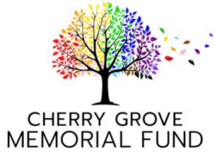

1. 501(c)(3) Organization Requesting Funding:

2. Contact Name:

3. Contact Email:

4. Contact Phone:

5. Proposal Summary:

6. Total Dollars Requested:

7. Budget Breakdown:

8. Project Timeline Start Date:

9. Project Timeline End Date:

10. If a grant request from CGMF does not cover full costs of the project, please indicate sources from which remaining funds will be raised (enter "N/A" if all costs will be covered):

11. Please briefly report on project outcomes for any funding received from CGMF in the past 3 years. If funding was received from CGMF but project was not completed, please provide project status and plans for project completion (enter "N/A" if no prior CGMF grants received):

12. Other Comments / Information